**Assignment – 2**

Dataset Programming

|  |  |
| --- | --- |
| Assignment Date | 19 September 2022 |
| Student Name | Mr. Mathan kumar |
| Student Roll Number | 111719205024 |
| Maximum Marks | 2 Marks |

**Question - 1:**

Download the Dataset from the link.

|  |
| --- |
| **Solution:** |
|  | The set is been downloaded (“ChurnModelling.csv”) |
|  | #----------------------------------------# |

**Question – 2:**

Load the dataset.

|  |
| --- |
| **Solution:** |
|  | df=pd.read_csv("Churn_Modelling.csv")  df.info() |
|  | #----------------------------------------# |

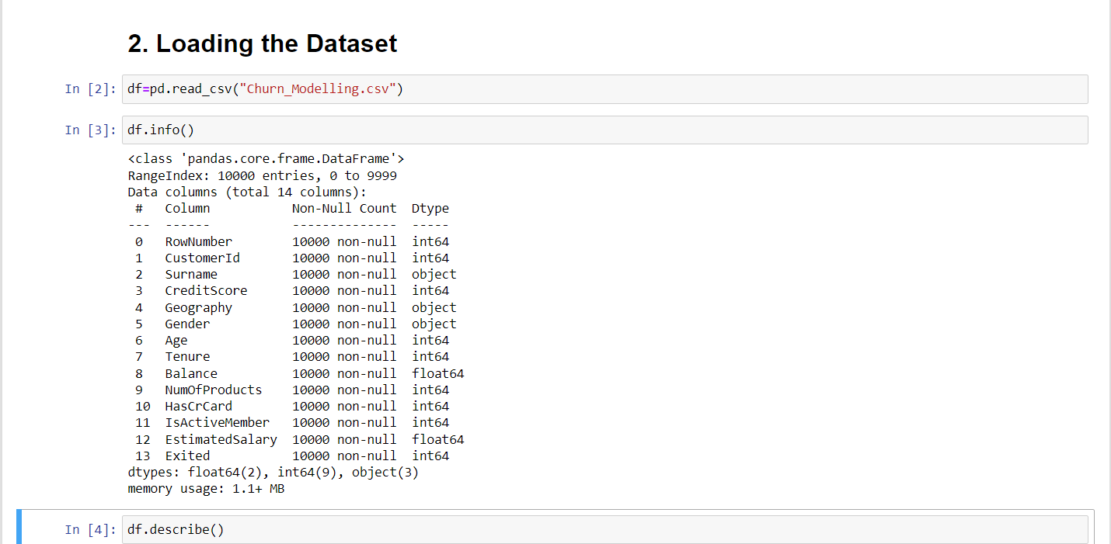

Question – 3:

Perform Below Visualizations:

Univariate Analysis:

**Solution:**

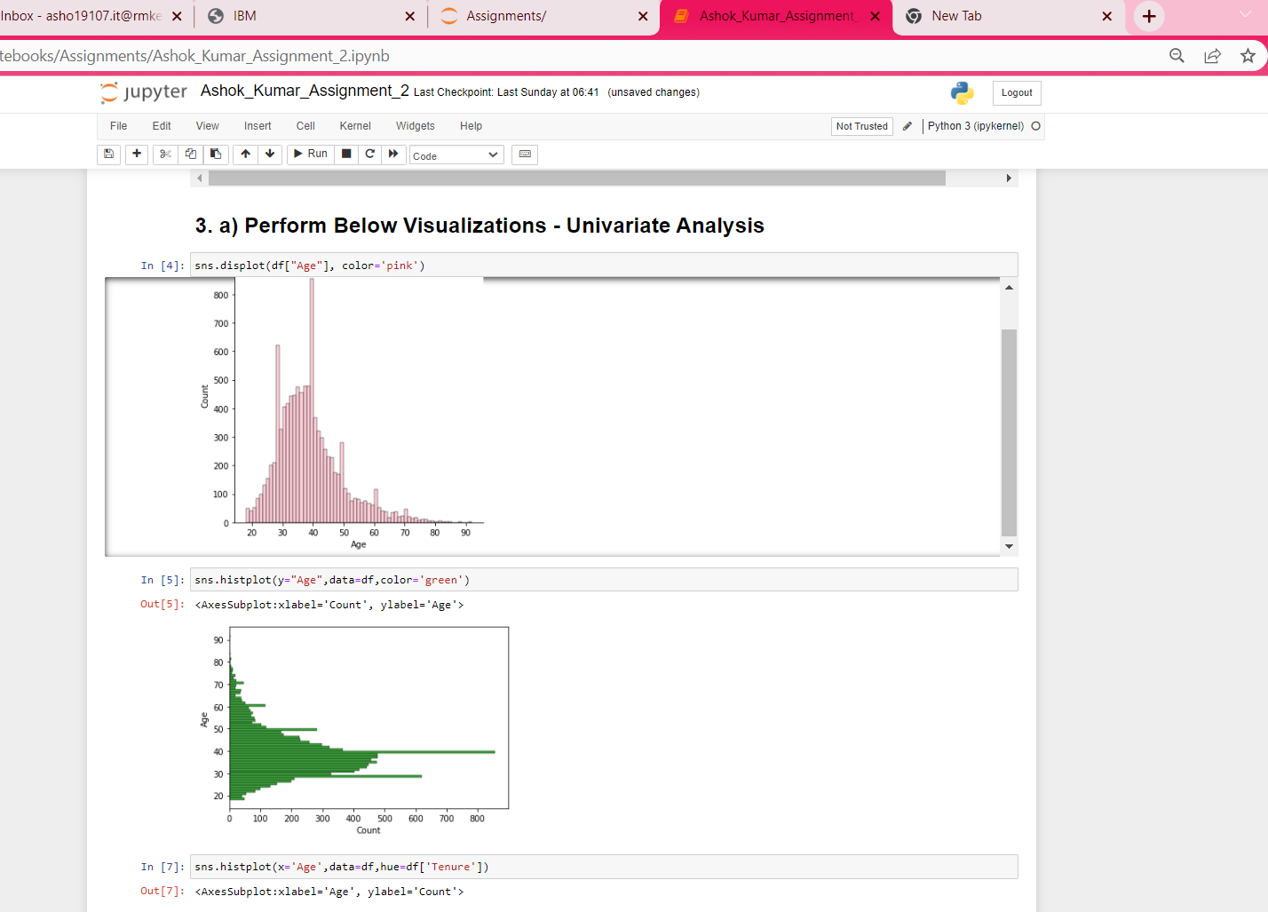

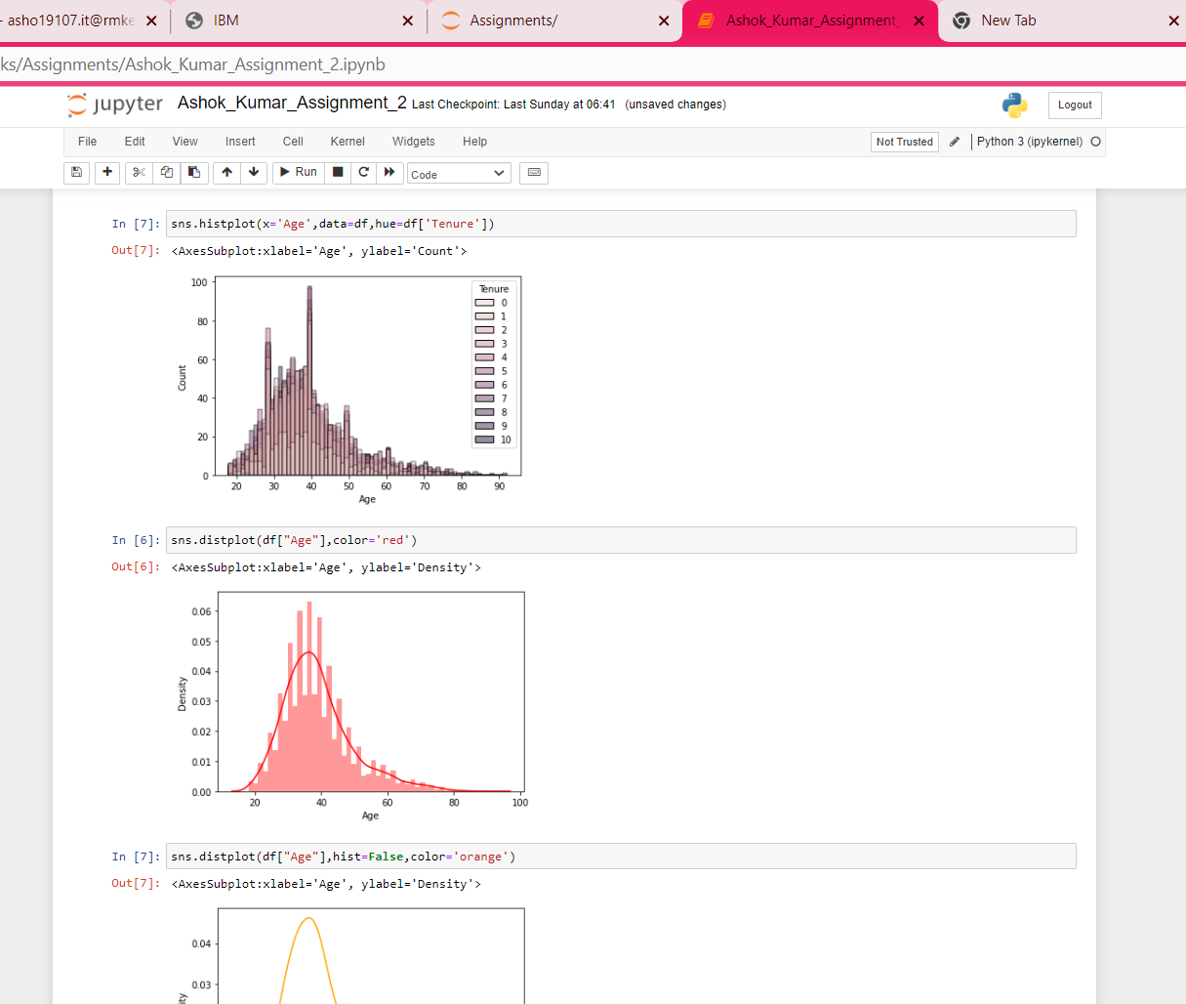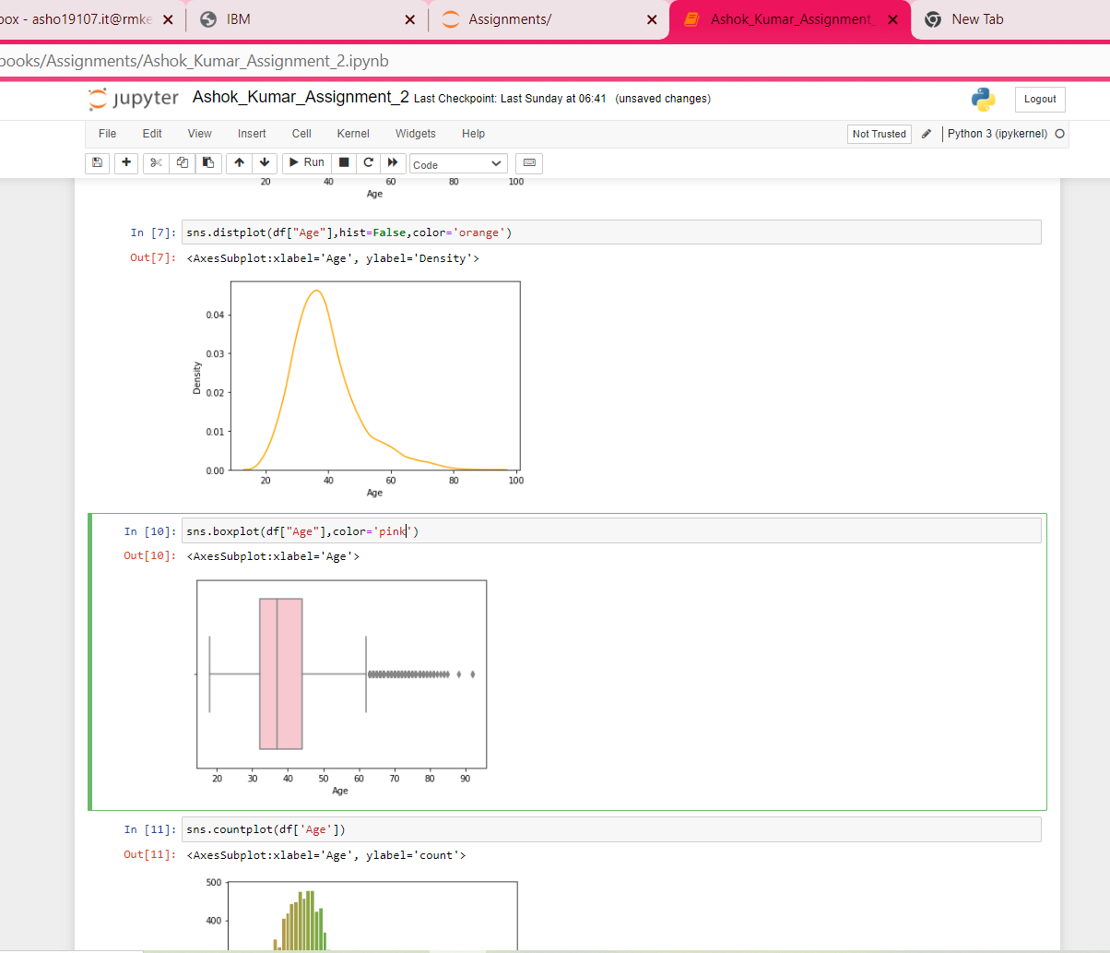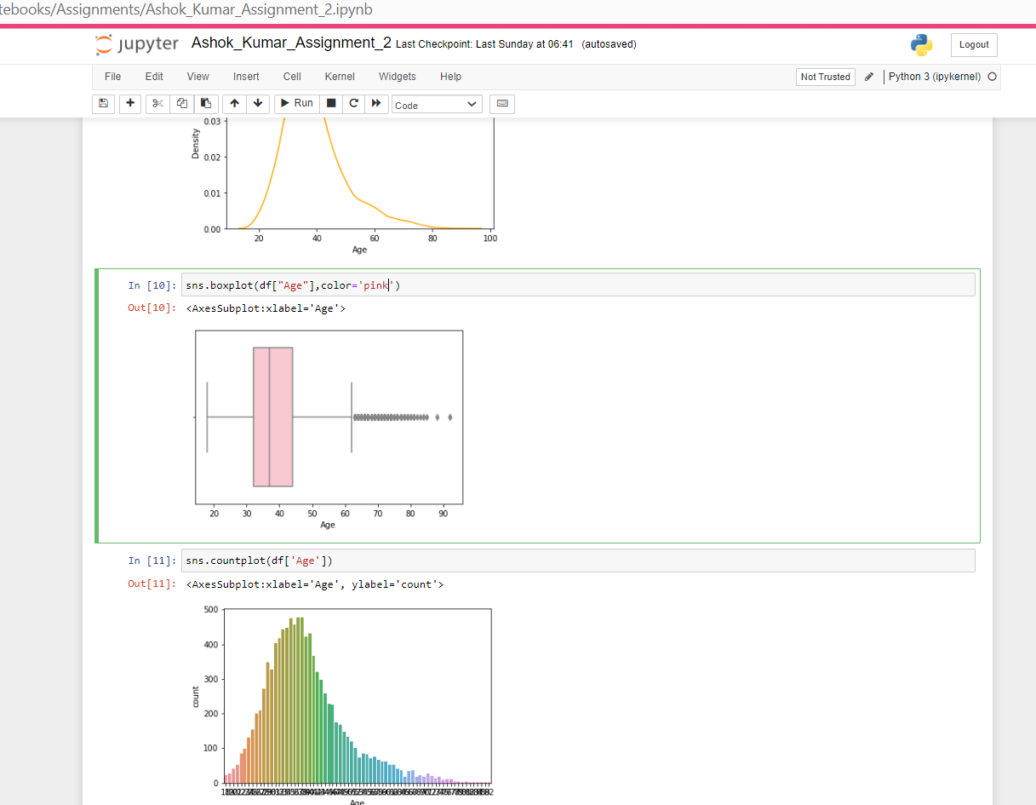

Perform Below Visualizations:

Bivariate Analysis:

**Solution:**

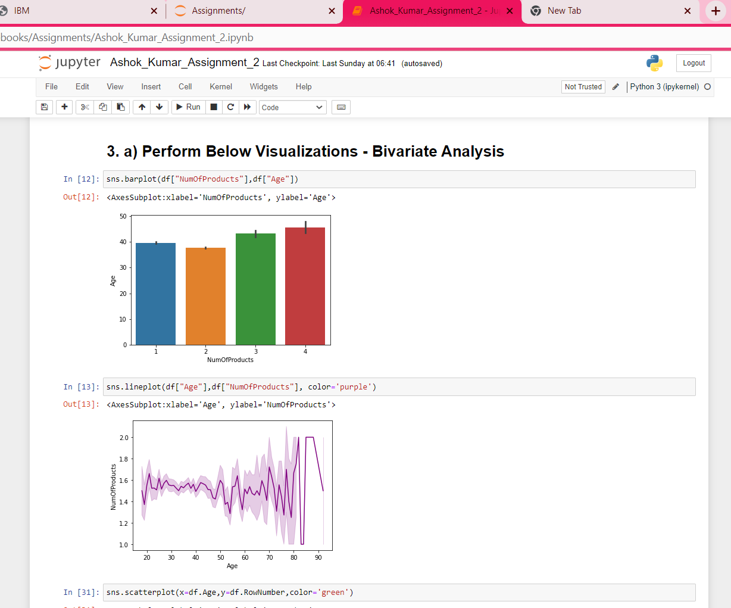

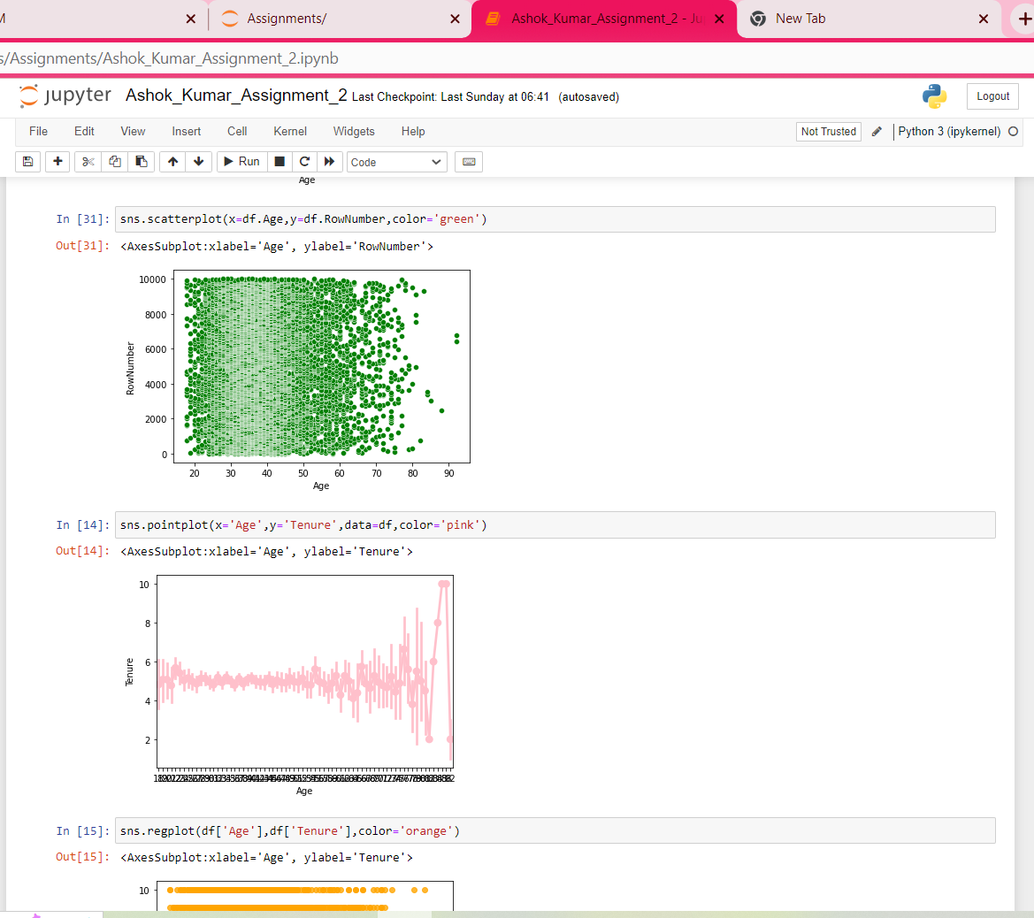

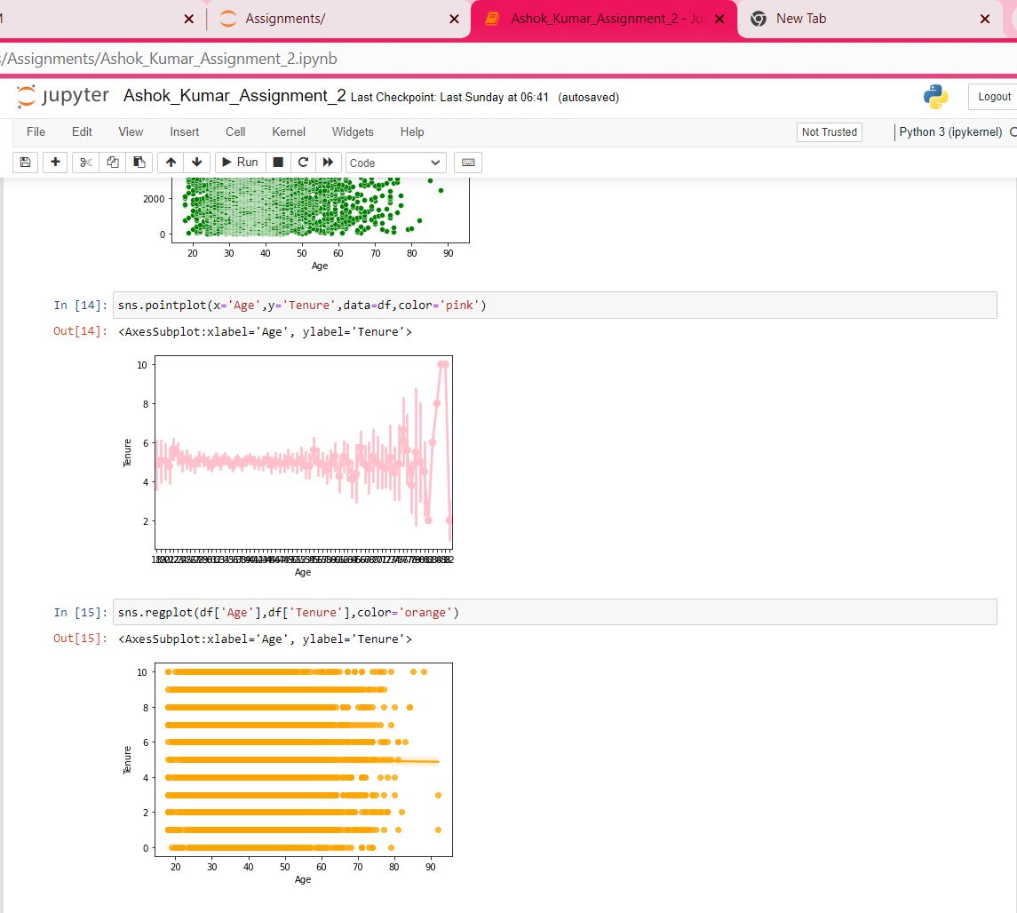

Perform Below Visualizations:

Multivariate Analysis:

**Solution:**

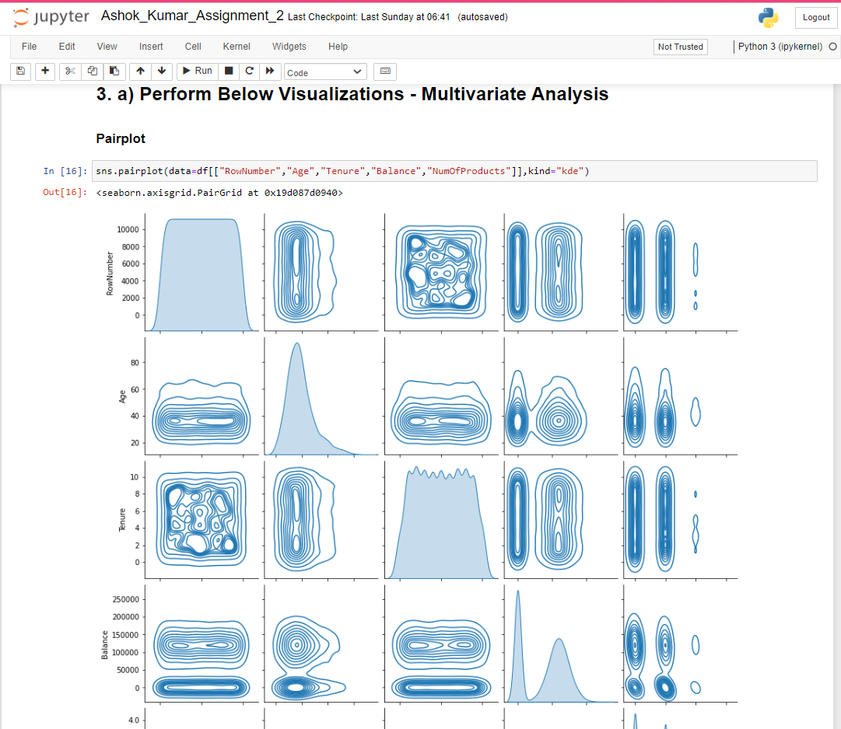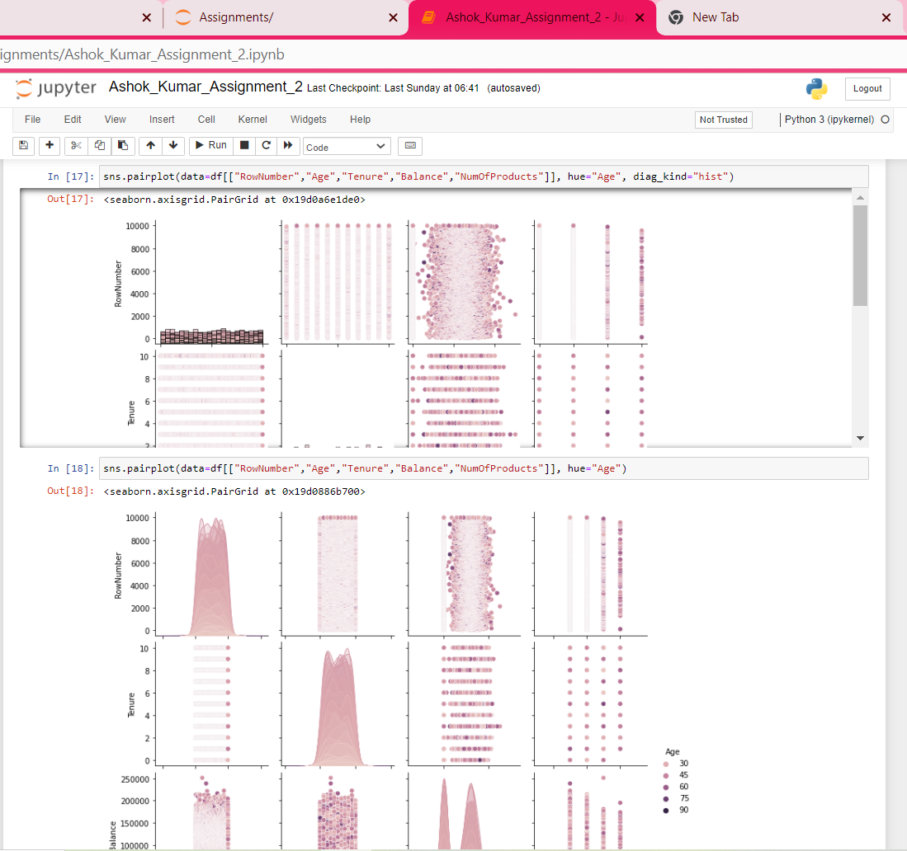

Question – 4:

Perform Perspective statistics on the dataset.

|  |
| --- |
| **Solution:** |
|  | df.describe() |
|  | #----------------------------------------# |

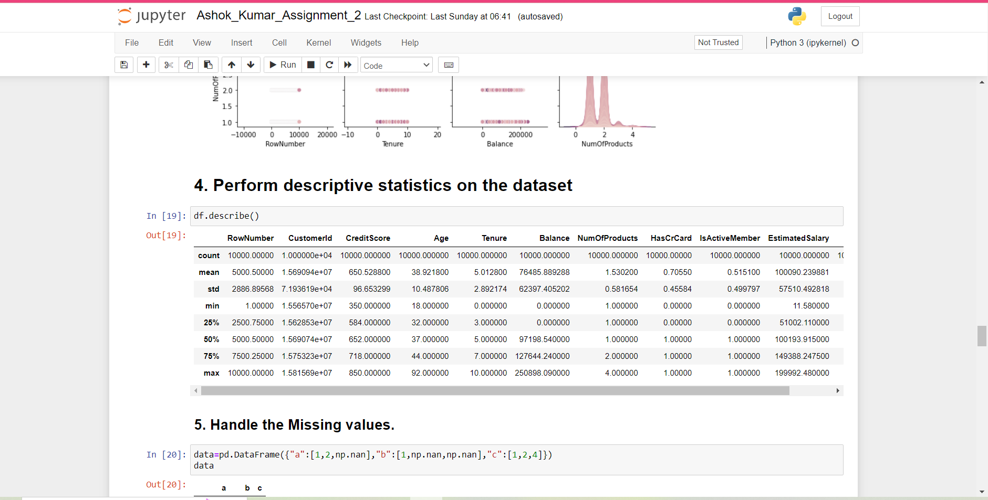

Question – 5:

Find the missing values

**Solution:**

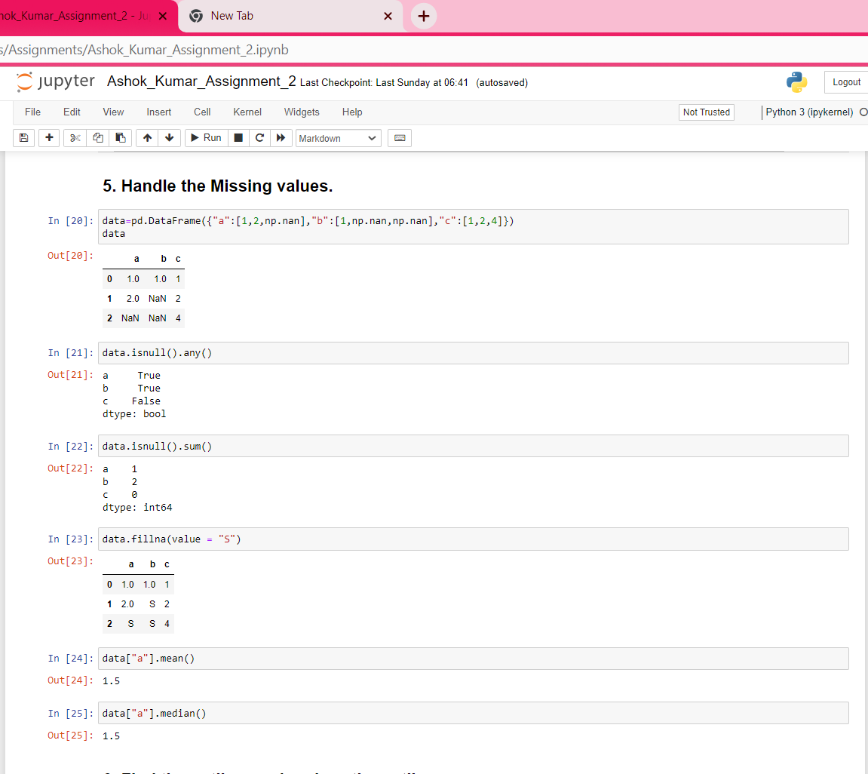

Question – 6:

Find the outliers and replace the outliers

Solution:

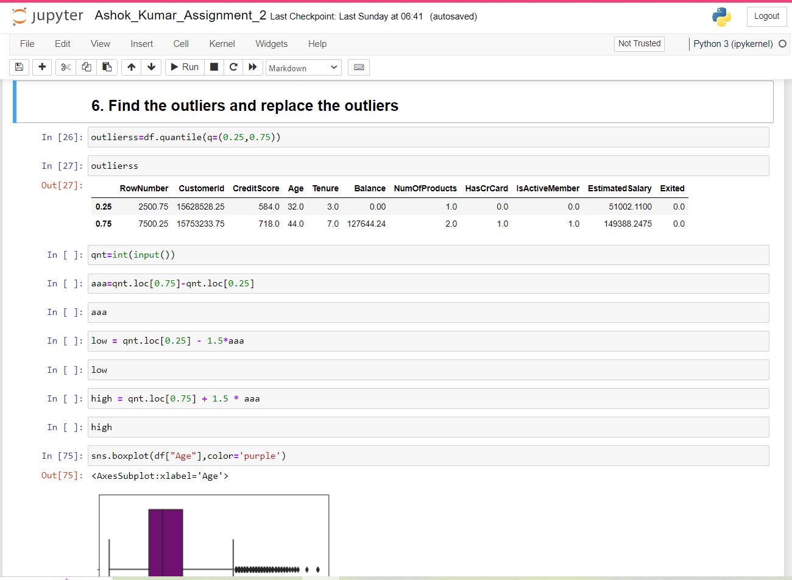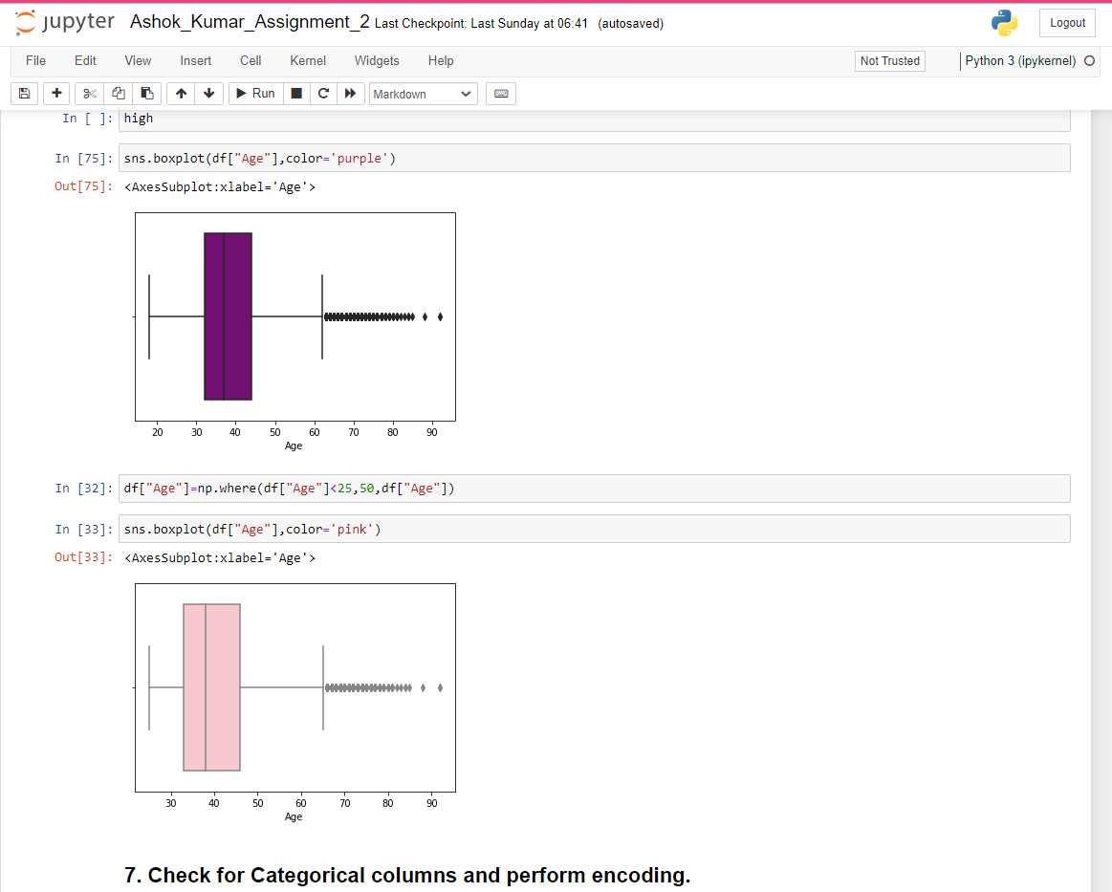

Question – 7:

Check for Categorical columns and perform encoding.

Solution:

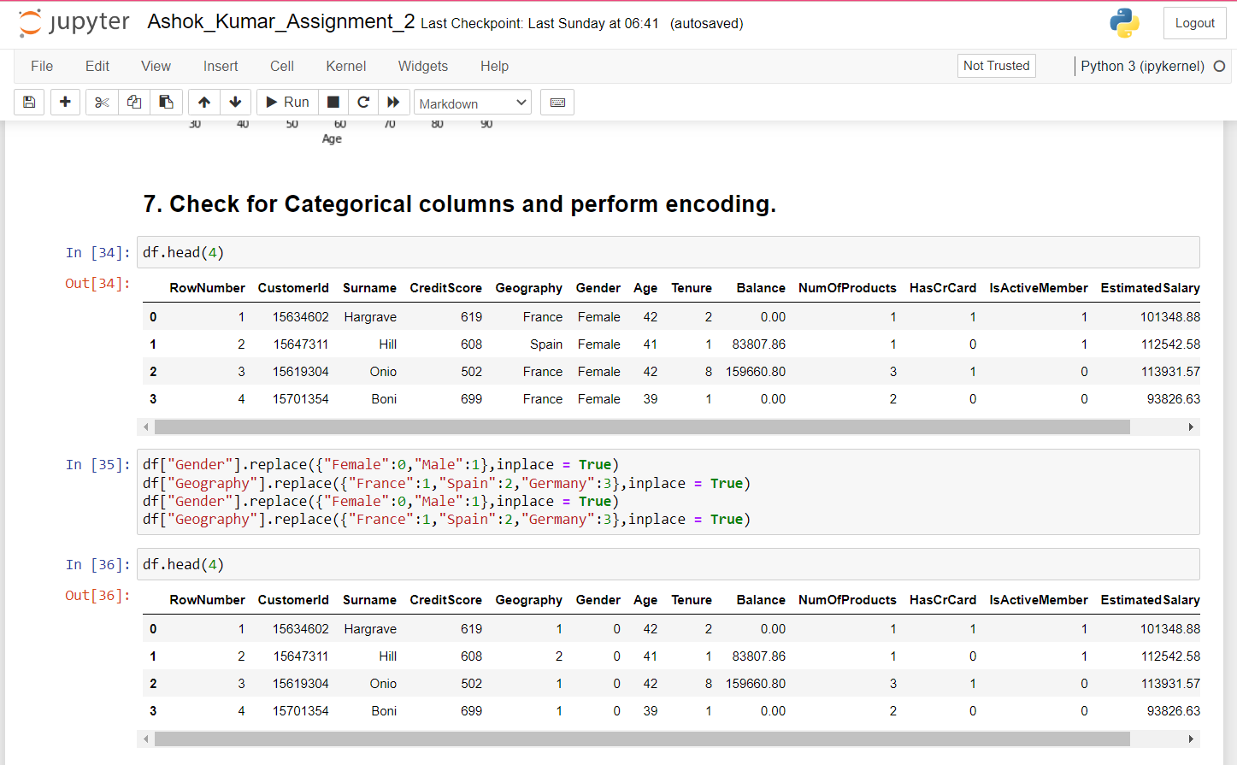

Question – 8:

Split the data into dependent and independent variables

Solution:

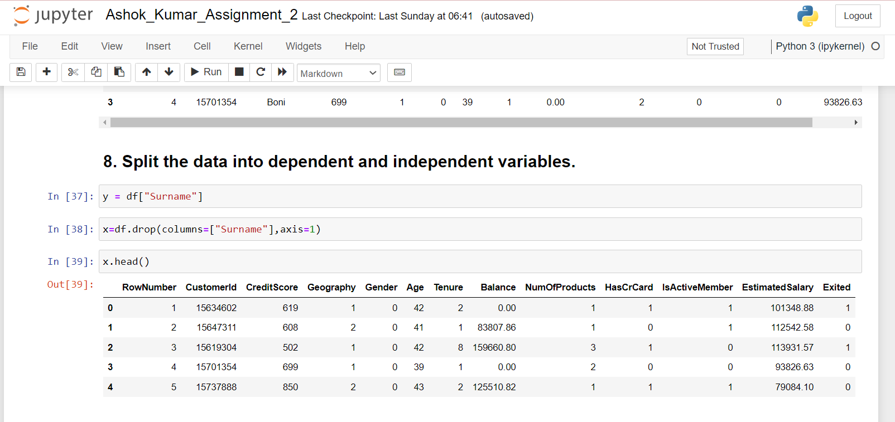

Question – 9:

Scale the independent variables

Solution:

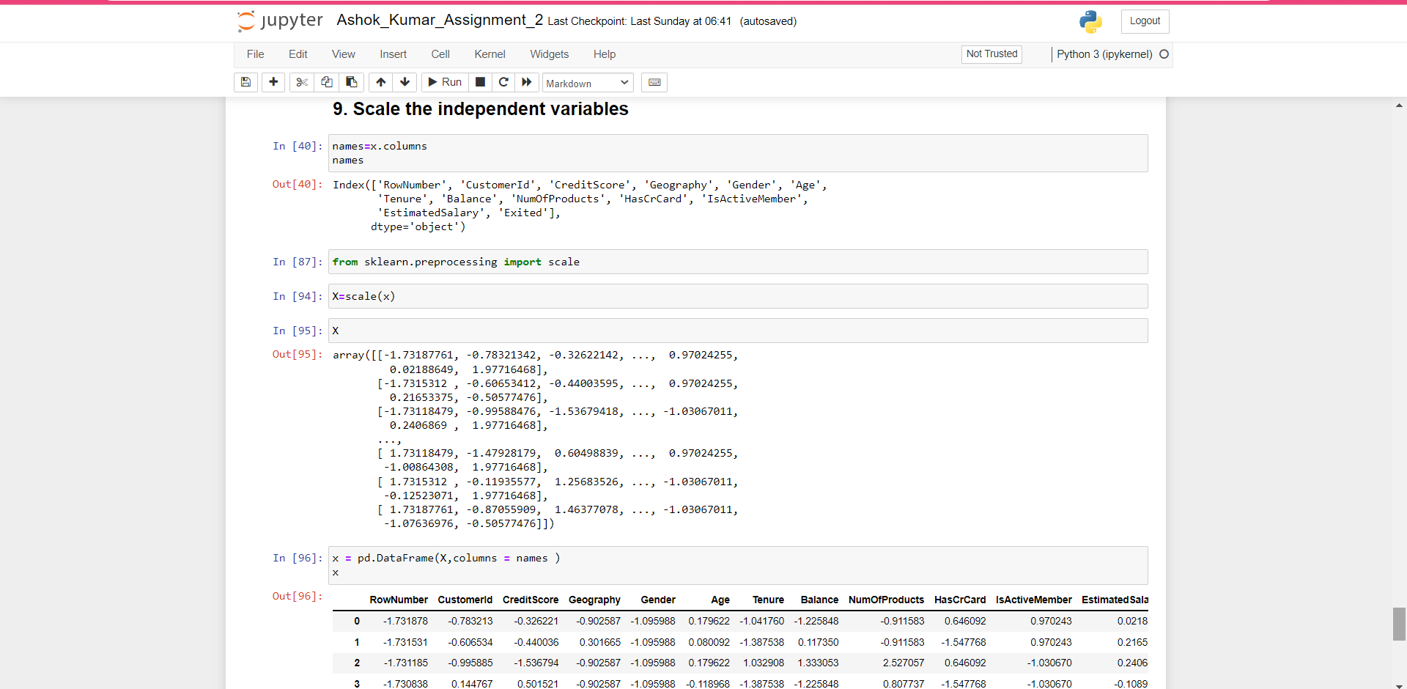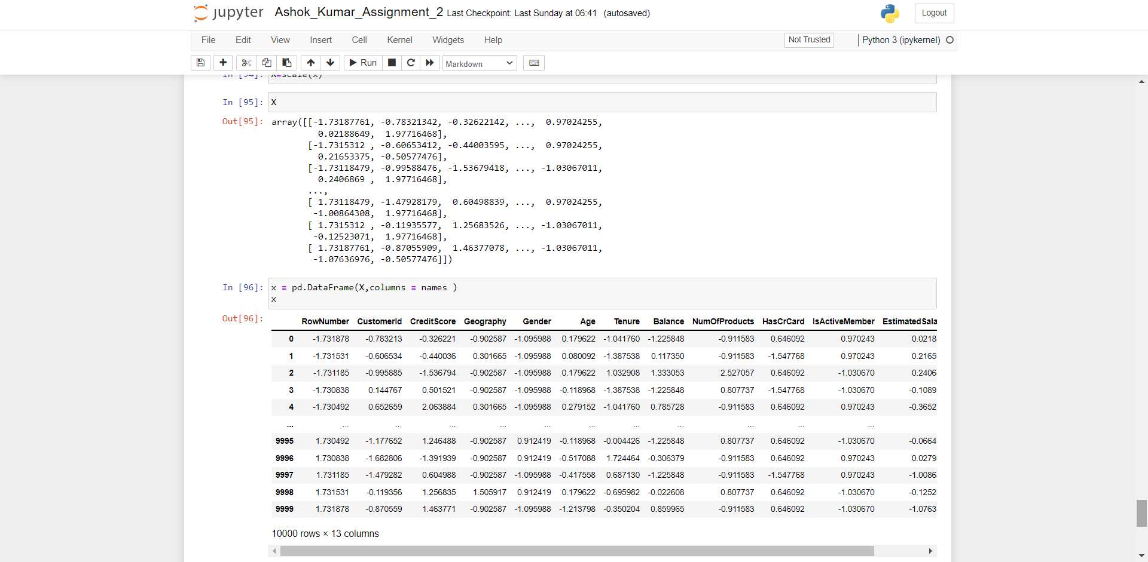

Question – 10:

Split the data into training and testing

Solution:

